Arduino LED & Potentiometer – Tinkercad Circuit Documentation

1. Aim / Objective
To design and simulate an Arduino UNO circuit in Tinkercad that controls multiple LEDs using digital output pins and reads a potentiometer value using an analog input.

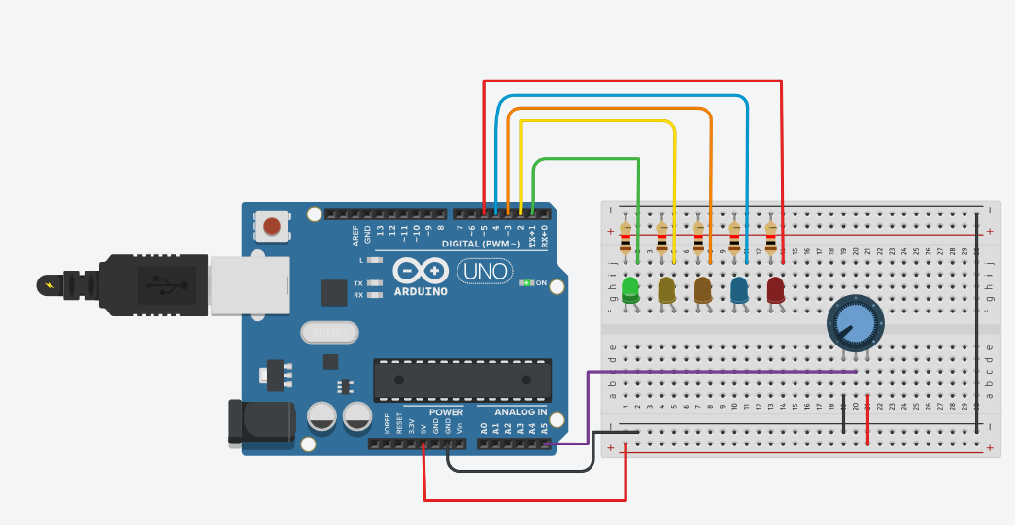

2. Components Required
- Arduino UNO
- Breadboard
- 6 × LEDs (any colors)
- 6 × Resistors (220Ω or 330Ω)
- 1 × Potentiometer (10kΩ)
- Jumper wires
- USB cable (for Arduino power

3. Circuit Description
The Arduino UNO supplies 5V power to the breadboard. Each LED is connected to a digital pin through a current-limiting resistor. The potentiometer provides a variable voltage to analog pin A0, which the Arduino reads to control the LED output pattern.
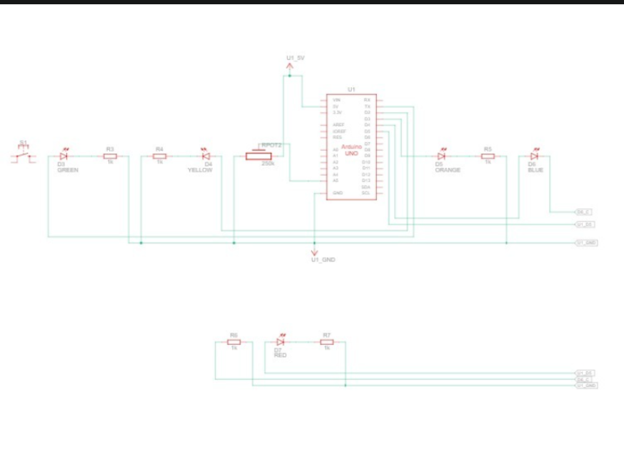

4. Power Connections
Arduino Pin | Breadboard Connection
5V | Positive rail (+)
GND | Negative rail (–)

5. LED Connections
Each LED is connected as follows:
- Anode (+) → Arduino digital pin via 220Ω resistor
- Cathode (–) → GND rail

Digital Pin Assignment
Arduino Pin | LED
D2 | LED 1
D3 | LED 2
D4 | LED 3
D5 | LED 4
D6 | LED 5
D7 | LED 6

6. Potentiometer Connections
Potentiometer Pin | Connection
Left pin | 5V
Middle pin | A0 (Analog Input)
Right pin | GND
The potentiometer acts as a voltage divider and sends a variable analog signal (0–5V) to the Arduino.

7. Working Principle
- Arduino powers the breadboard.
- The potentiometer position changes the voltage at pin A0.
- Arduino reads the analog value (0–1023).
- Based on this value, LEDs are turned ON or OFF.
- More LEDs glow as the potentiometer value increases.

8.Block Diagram

+-------------------+
| Power Supply |
| (USB / 5V) |
+---------+---------+
|
v
+-------------------+
| Arduino UNO |
| |
| - Digital Pins |-----> LED + Resistors (D2–D7)
| - Analog Pin A0 |<----- Potentiometer (10kΩ)
+---------+---------+
|
v
+-------------------+
| GND Reference |
+-------------------+

9. Arduino Program (Tinkercad Compatible)
int potPin = A0;
int leds[] = {2,3,4,5,6,7};

void setup() {
for(int i = 0; i < 6; i++) {
pinMode(leds[i], OUTPUT);
}
}

void loop() {
int potValue = analogRead(potPin);
int level = map(potValue, 0, 1023, 0, 6);

for(int i = 0; i < 6; i++) {
if(i < level)
digitalWrite(leds[i], HIGH);
else
digitalWrite(leds[i], LOW);
}
}

10. Applications
- LED level indicator
- Arduino basics learning
- Analog to digital conversion demo
- Tinkercad simulation practice

11. Conclusion
This Tinkercad circuit demonstrates how Arduino uses analog input to control multiple digital outputs. It is a beginner-friendly project for understanding LEDs, resistors, potentiometers, and Arduino programming.

link
https://www.tinkercad.com/things/8n UagxXPiD9N-funky-jaagub?sharecode=XALLNy6A4fgzZ_g68h4_8rzKmT-Cv9XowqoES_A83kc

